**JVP iOS App Instructions**

**Requirements:**

* Well-lit room (Lighting equipment if needed, such a lamp)
* Chair / sofa / pillows for patient to recline on
* Sticker set provided by physician
* Tripod provided by physician
* No red objects in the background when taking the video recording
* **Patient must have an assistant to help with the setup and video recording**

**Instructions:**

1. The patient must recline at a 30-45 degree angle, similar to the images shown below. Choose a place that is next to a wall with a solid color, such as a white wall, and make sure there are no objects that are red in the background when recording the video.

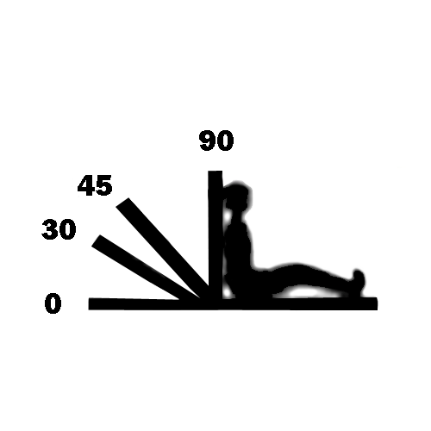

1. Next, open the app and place the phone flat on the chest with the screen facing up. If the patient is reclining at an appropriate angle for the measurement, the box at the lower left hand corner of the screen will be green. If the angle is incorrect, the box will be red. Adjust the patient’s position until the box is green. Below is a screenshot of this.

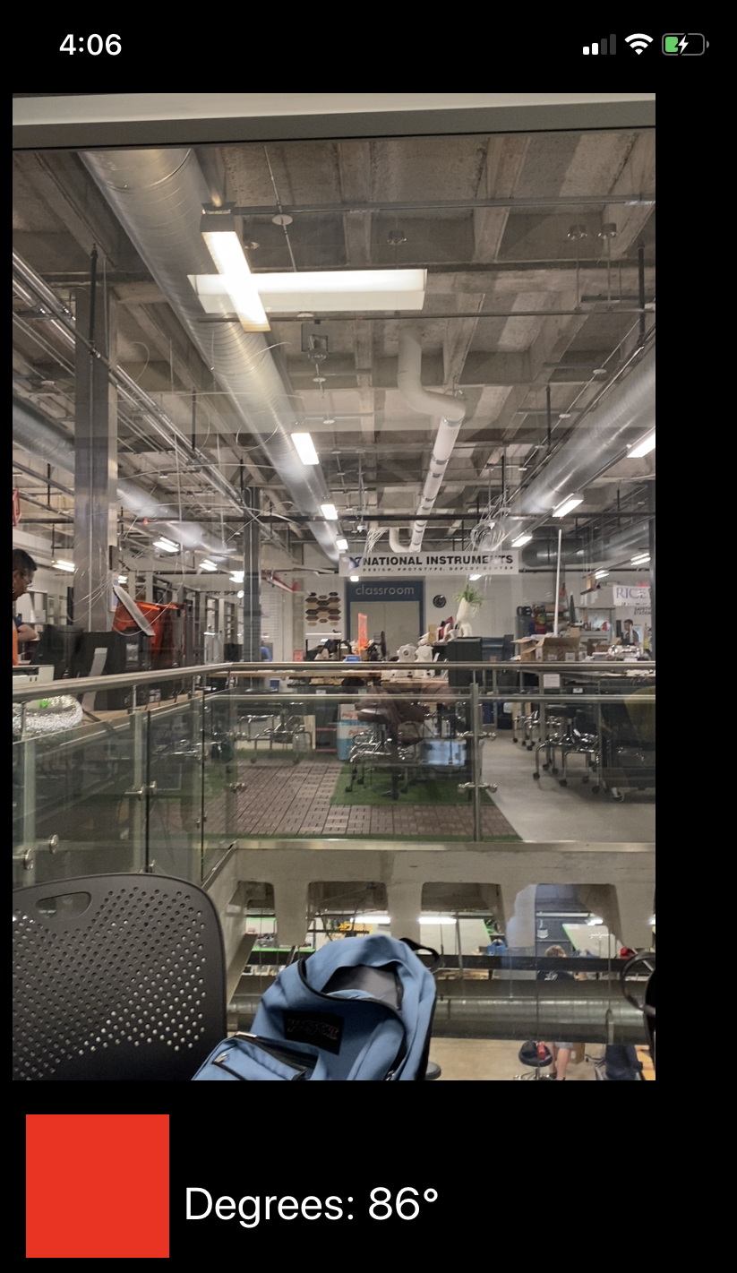 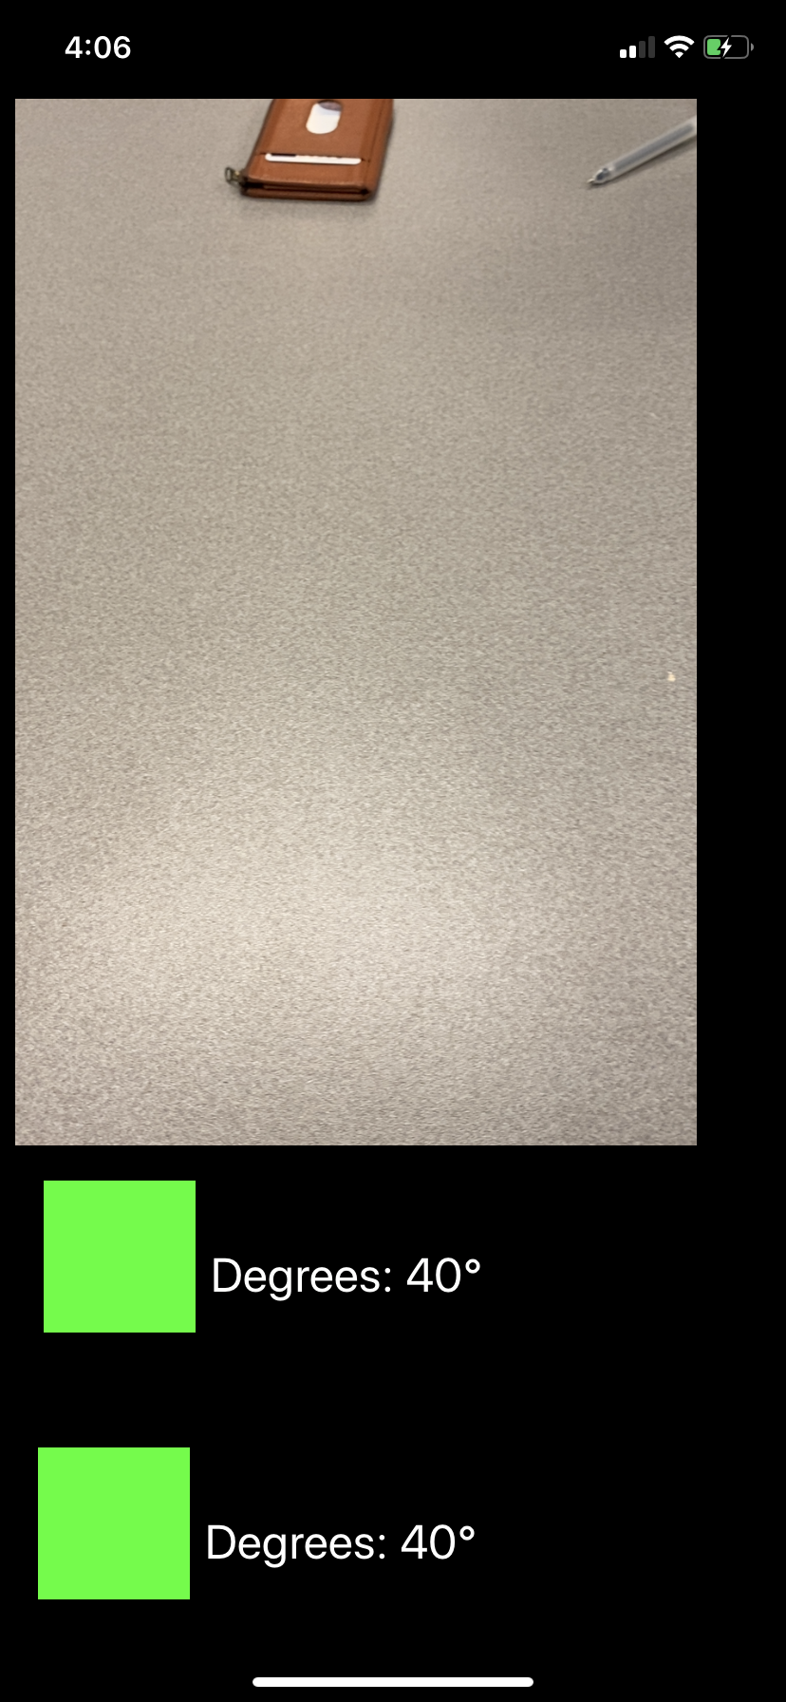

*Red box: angle is not in correct range Green box: angle is in the correct range*

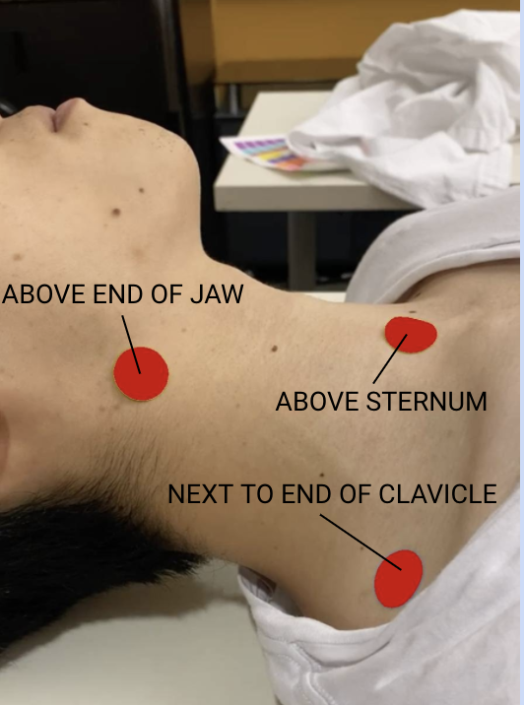

1. Put a tripod on the right side of the patient’s chair so that the camera faces the right side of the patient's neck. The assistant must put the phone on the tripod and make sure that the right side of the patient’s neck is clearly shown on the screen. To the left is a good reference for how the video should look after set up. Try to get the camera as close to the neck as possible so that the stickers are near the edges of the screen.
2. Next place stickers on the patient. There should be three stickers for the patient. One must be right below the end of the jaw. One must be next to the end of the clavicle. One must be right above the sternum. The same image has these instructions referenced.

1. The assistant must press the box on the lower left hand corner to start recording. Once pressed, there will be a 5s time delay before recording starts. As shown below, there will be a message saying “Starting” displayed to indicate this delay.

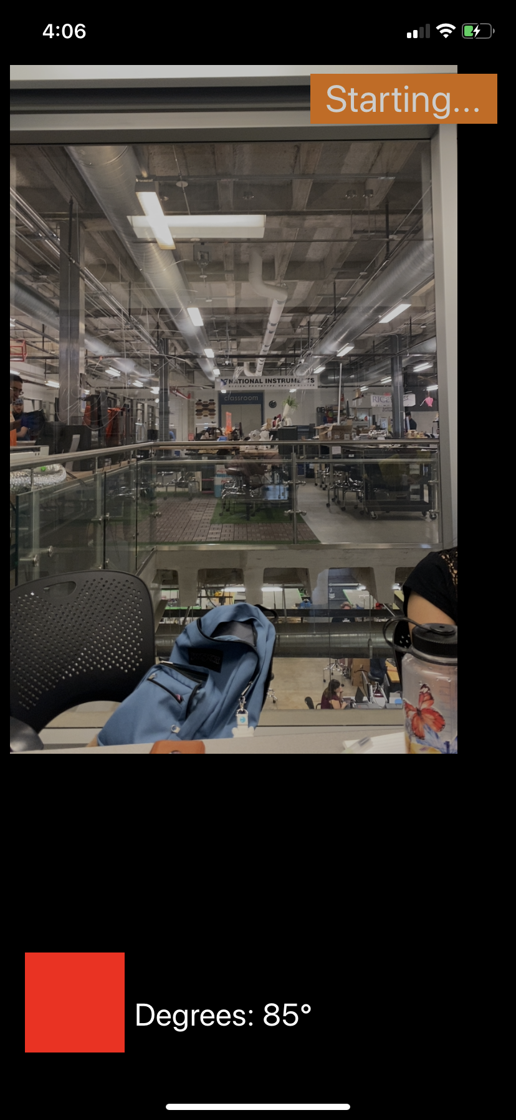

*Starting, displayed at the top, indicates that there is a delay before video starts recording*

1. The app will automatically take a 10s video recording.
2. If you are satisfied with the recording, press the Send button.
3. An alert box will pop up to enter the patient’s ID.
4. An email message with the recording as an attachment will be shown. Click the send symbol on the upper right hand corner of the page to send the recording to the physician.

